Alyce Kang

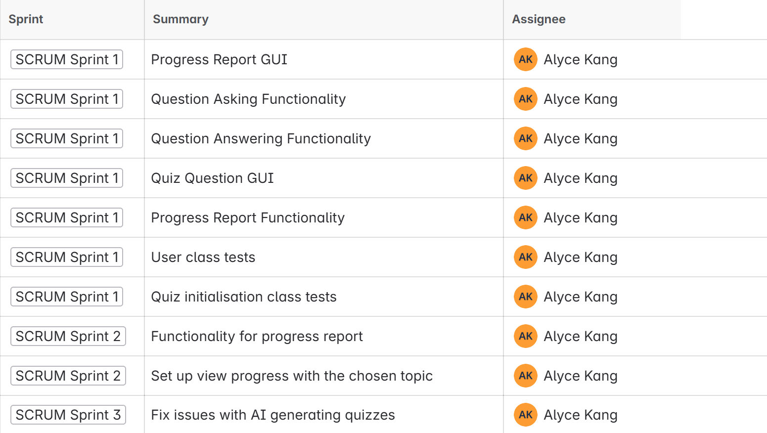

Angelica Siv

Nicholas Holmes

George Panayides

Joel Jacob

